1. **Deploy An Simple application using manually in Docker**

First Create EC2 Instance and allow all traffic to EC2 Server and install docker in EC2 instance.

1. Start the docker.

2. Pull Ununtu Image or Linux Image from Docker Hub.

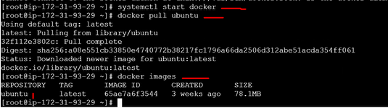

3.Now I want to deploy the application in the OS. Than login in image to run in container than check what are the process are running in container.

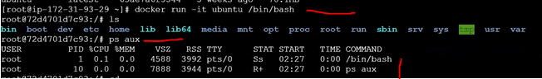

4. Than create a folder as python than inside that folder do everything. Than check if dependencies(python,flask,pip) are present or not. Otherwise download the dependencies. I am doing everything inside the container.

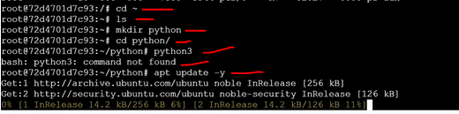

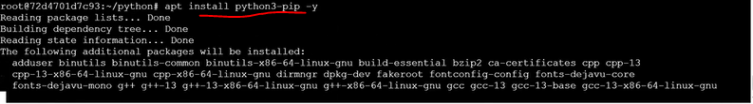

5. Creating a python file and saving my code Than enter and exit.

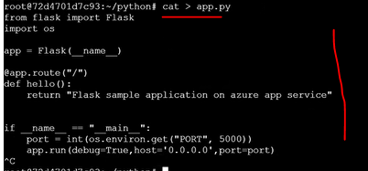

6. When we will run the python code than it will through error. Than we will download the dependency.

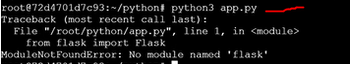

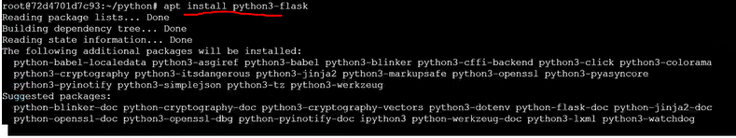

Than Run the python app and its interative mode. But we started **/bin/bash** as **it** mode and if we will exist than container will stopped otherwise we will quite the process and still the process will run.

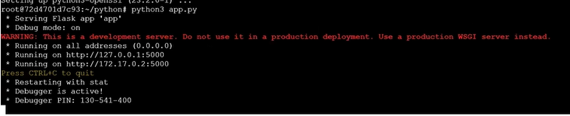

7. Dockerfile commands.

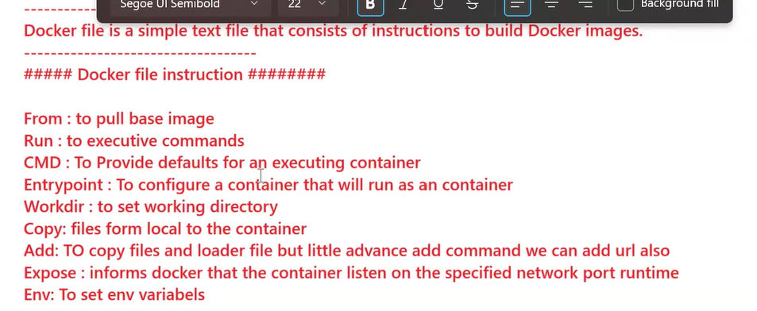

8. Below Steps we did manually. We will do using Dockerfile.

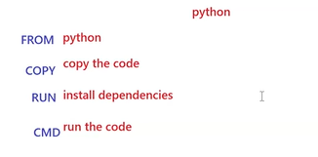

**Deploy An Simple application using DockerFile In The Repo**

1. In EC2 instance first install git.



1. Clone the project and give that path in Dockerfile for copy or create a python folder and inside that create app.py file and paste the code and save.

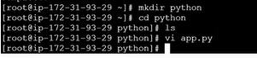

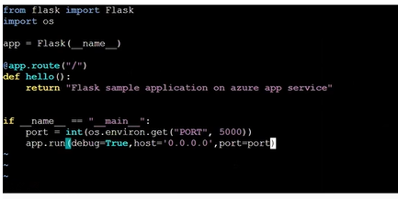

1. Than create a requirement.txt for dependency.



1. EC2 instance is local. If we want to run in EC2/Local than we need to install python , pip and flask and run. But I don’t want to run in EC2 I want to run my code in container.

I want to all the process should automate in Dockerfile.

1. Create a Dockerfile like this.

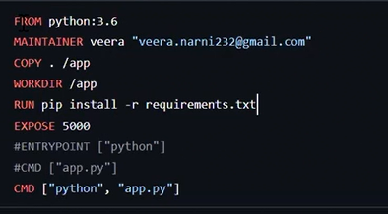

1. Build the docker file to create a image.



**COPY** Means It will download the local code to inside given folder name in Container. It Take code from EC2 and Create folder like app inside container and clone the code into app folder. Than Inside container check app folder created and all the codes are copied into app folder.



Remove Unwanted images.

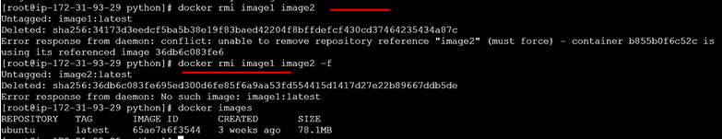

**WORKDIR app** Means Set the app folder in container i.e **cd /app** Than when we will run than it will automatically set to app directory.



**RUN** Install the dependency given file name present in app folder.

**CMD** It will run the app. When we will build everything will execute but CMD will not. When we will run the image than CMD command will start.

1. Through docker command check docker image is there or not . If it present than run the container it will fire the CMD command which one we write in Dockerfile.

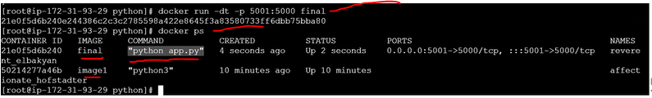

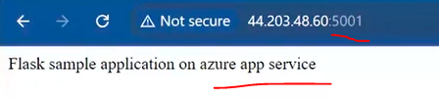

1. If you will do a small changes in Dockerfile than you need to build it. Image name also change how many times we will build based on change.

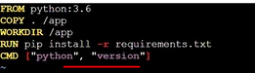

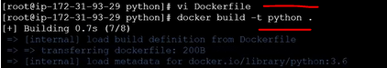

1. If we will run the image than it will terminate because Python version CMD command is not continuous run it will run and stop.



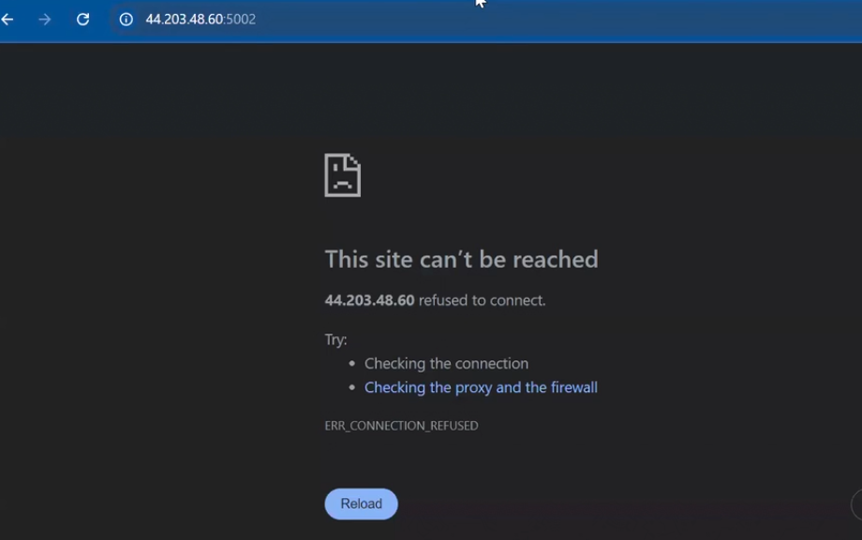

1. Same Two Process is running.



1. To check container logs.



1. This command only for Running Containers.



1. Here we did manually OS ubuntu setup manually in container. If we will execute below code in docker file than OS will pull from docker hub and will install the python,pip,flsk than run in CMD.

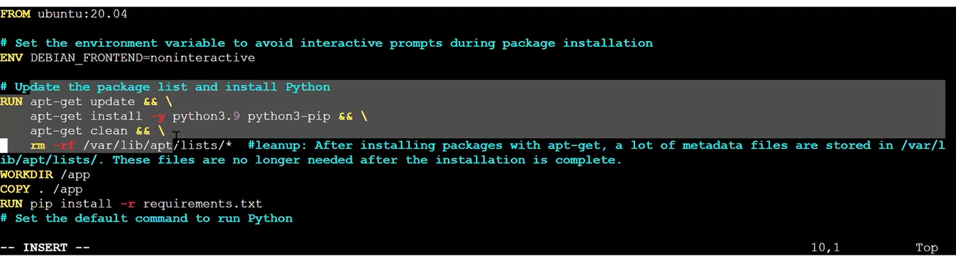

ENTRYOINT Means Value is fixed and will append in CMD Values.

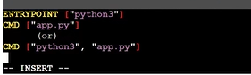

1. Than Run the image in **dt** mode.
2. Please do the Project given.